UNIT: CIVIL RIGHTS AND THE STRUGGLE FOR EQUALITY
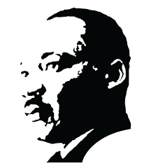
BIG IDEA: Marginalized groups experienced an expansion of their rights through increased public awareness, protest, legislation, and Supreme Court decisions.

BIG QUESTION: How did groups fights for equality during the 1950s, 1960s, and 1970s?

CONCEPTS | Broken Promises | Civil Rights Movement | Government Actions | Other Groups
LESSON  ESSENTIAL QUESTIONS | 1. How have Civil Rights evolved over time?  2. How have promises from the Civil War and Reconstruction Eras not been fulfilled in the past century? | 3. How did the various approaches to Civil Rights differ in philosophy, efforts, and success?  4. What role did Civil Rights proponents and detractors play in the fight for equality (groups and individuals)? | 5. What legislation, court cases, and executive orders advanced the Civil Rights movement? | 6. How did the efforts of other marginalized groups (women, Latin Americans, LGBTQ, Native Americans) parallel that of the plight of African Americans?
CRITICAL  VOCAB. | Disenfranchisement | Demonstrate | Legislation

