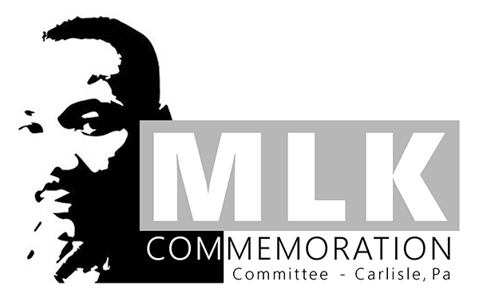
“Pursuing the Dream: Uniting in Truth and Love”
Rev. Dr. Martin Luther King, Jr.
Project and Showcase
2020-2021
Grades K-12

Project Prompt:
This year’s theme, “Pursuing the Dream, Uniting in Truth and Love,” highlights the continued importance of uniting with one another in love. It also urges us to confront the truth of our moment – to examine what continues to divide us in an effort to bring us closer to one another – and closer to Dr. King’s dream.
Create a project that explores and/or expresses this year’s theme, taking into consideration your community (however you define it) as well as the greater life and work of Rev. Dr. Martin Luther King, Jr. Some questions to consider might include:
- How would Dr. King define “the dream”? What does his dream look like today?
- How did Dr. King’s work seek to attain “the dream”?
- What continues to divide us? How can we confront and examine those divisions in order to come closer to one another and to Dr. King’s dream?
- Where in your community do you see evidence of individuals or groups “pursuing the dream”?
- How can you “pursue the dream” within your community?
- How can you acknowledge the truth of our moment while seeking to unite in love?
- Where in your community do you see evidence of individuals or groups confronting the truth of the current moment?
- How can we take Dr. King’s lofty vision and apply it in practical ways within our own community?

Possible Formats for Submissions:
The current circumstances surrounding COVID-19 will impact not only the format of this year’s commemoration event, but also the way in which we will collect entries. To accommodate the nature of this year’s commemoration event, we encourage students to make a simple statement about this year’s theme – perhaps one that responds to one of the questions listed above. A one-sentence response is perfectly acceptable, for example, and the submission form allows for this. However, we will still accept projects in the following forms:

- arts or performance arts projects
- whole-school or all-class initiatives, events, or projects
- social action/social justice project
- service projects
- videos, essays (analytical, persuasive, or personal), cartoons, short stories, poetry, narratives, letters, multi-media projects, multi-genre projects, personal statements
- Whatever students can imagine, we will welcome!

All entries should be submitted electronically via this FORM by Monday, January 4, 2021. If a student completes a poster or other 2- or 3-demensional project, the student should take pictures of the project and attach them to the submission form. Some projects will be featured at the Commemoration event. ALL project submissions will be featured on the Carlisle Area School District website.

